Wallace State Community College Library Staff
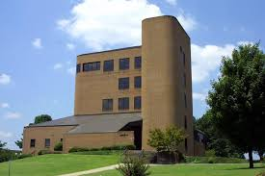
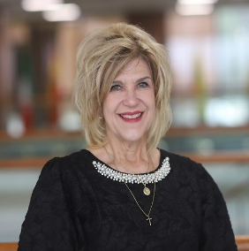
Renee Marty
Head Librarian
256-352-8267 or 256-352-8420
renee.marty@wallacestate.edu
801 Main Street NW
Hanceville, AL 35077

Kayla Aaron
Library Assistant
256-352-8259 or 256-352-8270
kayla.aaron@wallacestate.edu
801 Main Street NW
Hanceville, AL 35077

Iman Humaideh
Library Assistant
256-352-8263 or 256-352-8259
iman.humaideh@wallacestate.edu
801 Main Street NW
Hanceville, AL 35077
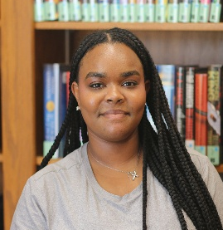
India Flanigan
Part-Time Library Assistant
256-352-8260
A02352905@alabama.edu
801 Main Street SW
Hanceville, AL 35077

Judie Carden
Evening Adjunct Librarian
256-352-8260
judie.carden@wallacestate.edu
801 Main Street NW
Hanceville, AL 35077

Brenda Dillashaw
Evening Adjunct Librarian
256-352-8260
brenda.dillasahw@wallacestate.edu
801 Main Street NW
Hanceville, AL 35077

Deonne Pugh
Evening Adjunct Librarian
256-352-8260
deonne.pugh@wallacestate.edu
801 Main Street NW
Hanceville, AL 35077

